[YourProject] Requirements Specification

Version 1.0

April 19, 2021

Use this Requirements Specification template to document the requirements for your product or service, including priority and approval. Tailor the specification to suit your project, organizing the applicable sections in a way that works best, and use the checklist to record the decisions about what is applicable and what isn't.

The format of the requirements depends on what works best for your project.

This document contains instructions and examples which are for the benefit of the person writing the document and should be removed before the document is finalized.

To regenerate the TOC, select all (CTL-A) and press F9.

**Table of Contents**

**[YOURPROJECT] REQUIREMENTS SPECIFICATION 1**

**VERSION 1.0 1**

**APRIL 19, 2021 1**

**1.** **EXECUTIVE SUMMARY 3**

1.1 Project Overview 3

1.2 Purpose and Scope of this Specification 3

**2.** **PRODUCT/SERVICE DESCRIPTION 3**

2.1 Product Context 3

2.2 User Characteristics 3

2.3 Assumptions 3

2.4 Constraints 3

2.5 Dependencies 4

**3.** **REQUIREMENTS 4**

3.1 Functional Requirements 5

3.2 Non-Functional Requirements 5

*3.2.1* *Product Requirements 5*

**3.2.1.1** **User Interface Requirements** 6

**3.2.1.2** **Usability** 6

**3.2.1.3** **Efficiency** 6

3.2.1.3.1 Performance Requirements 6

3.2.1.3.2 Space Requirements 6

**3.2.1.4** **Dependability** 6

**3.2.1.5** **Security** 7

*3.2.2* *Organizational Requirements 7*

**3.2.2.1** **Environmental Requirements** 7

**3.2.2.2** **Operational Requirements** 7

**3.2.2.3** **Development Requirements** 7

*3.2.3* *External Requirements 7*

**3.2.3.1** **Regulatory Requirements** 7

**3.2.3.2** **Ethical Requirements** 7

**3.2.3.3** **Legislative Requirements** 7

3.2.3.3.1 Accounting Requirements 7

3.2.3.3.2 Security Requirements 7

3.3 Domain Requirements 7

**4.** **USER SCENARIOS/USE CASES 7**

# Executive Summary

## Project Overview

Describe this project or product and its intended audience, or provide a link or reference to the project charter.

## Purpose and Scope of this Specification

The purpose of this specification is to assess the current state of the product design and to document the entire process based on design issues and the audience.

This specification encompasses several aspects of the process being discussed in as broad scope as possible. Thus, in this scope we address the following:

* In depth documentation of the features of the product,
* Technical overview of the system processes and views,
* This is discussed in Part 2.1 and throughout the document,
* User and System Requirements,
* Components & Functional/non-functional requirements,
* These are discussed in Part 3 in some detail,
* Definition of users’ means of using and accessing the product,
* Use cases/scenarios discussed in Part 4,
* Dependencies and Constraints,
* These are discussed in Part 2.4/5 of the Document,

Aspects not included in the scope are as follows:

* Legislative requirements for the product
* Auditing and financial considerations of the product

# Product/Service Description

This app is designed to provide an easy and efficient way for users to purchase medicine and skincare products. Users can browse through a wide selection of products and place orders with just a few taps on their phone. Additionally, users can bookmark items and set a reminder to repurchase at a later date.

For clerks, the app provides an intuitive interface for managing inventory, processing orders, and tracking shipments. The app makes it easy to add new products, update prices, and manage stock levels.

For managers and owners, the app provides access to real-time sales data, inventory reports, and customer feedback. The app also makes it easy to manage promotions and discounts, as well as track the performance of individual products. Overall, the app streamlines the process of buying and selling medicine and skincare products for both consumers and businesses.

## Product Context

## PharmaLine is a revolutionary application designed to make shopping for pharmaceutical products more accessible and convenient. Its purpose is to simplify the process of purchasing prescription medication and over-the-counter drugs, while also providing a comprehensive resource for clients and healthcare professionals.

## PharmaLine is designed with the user in mind and is focused on providing a high level of accessibility and convenience. It offers an intuitive interface that makes it easy to search for and purchase the products that clients need. The application also provides a wealth of information on the medications, including dosage, side effects, and potential interactions with other drugs.

## By offering a cloud-based solution, PharmaLine eliminates the need for patients to visit multiple pharmacies in person or make phone calls to check availability or prices. The application allows clients to easily access a wide range of pharmaceutical products.

## With PharmaLine, client can rest assured that their medical information is kept secure and private. The application is compliant with all necessary regulations and provides a safe and secure platform for clients to manage their healthcare needs.

## PharmaLine is a game-changer for the pharmaceutical industry, offering a more accessible, convenient, and user-friendly solution for clients and healthcare professionals.

## User Characteristics

**Customers :**

* Can use PharmaLine to browse and purchase pharmaceutical items
* Checks purchase history and gives feedback on items
* Rates items based on personal experience
* Uses a wishlist to pre-order items that are out of stock or unavailable
* Makes use of personalized product suggestions
* Pays using a variety of payment methods, including credit cards, debit cards, and digital wallets
* Tracks orders and compares products
* Interacts with social networking platforms through the app
* Can be use by wide range of individuals from teenagers to elderly people
* Elderly people who may have mobility or transportation issues and prefer the convenience of ordering their medications online and they can also save time by bookmarking items and setting reminders to purchase them at a later date.
* Teenagers or adults who can be more interested in skincare and want to browse for items, leave comments, and read reviews.

**Managers:**

* Add or delete offers and discounts in the blog section
* Manage the inventory and product listings
* Check daily sales and monthly sales reports
* Administer the blog section

**For Clerks:**

* Check the items bought by a single user or the list of purchasers for a particular product
* Add and delete products
* Inspect product listings and availability
* Help customers with any issues related to the app

**Business Owners:**

* Access all features available to managers and clerks
* Monitor the overall performance of the store
* Make strategic decisions based on the sales data and user feedback

## Assumptions

* It is presumed that every user is familiar with the fundamentals of handling electronic equipment (e.g., smartphones, tablets, computers, etc.).
* In order to access the webpage, the electronic device must be online.
* Electronic devices are assumed to one of the after mentioned operating systems: Microsoft Windows, Android OS and Apple IOS.
* Users of all ages should be able to quickly navigate the website thanks to its simple and user-friendly interface.
* User data that is entered or collected by the system, is assumed to only be used by the shipment company.
* It is assumed that the team won't falter along the road and that the project's cost won't fluctuate during development.

## Constraints

There are a number of items that will likely constrain the design options, including:

* The diverse age target, our system is aimed at both younger and older audiences, ranging from teenagers to the elderly, which creates issues regarding the design of a user-interface modern enough to entertain the youth, while simultaneously being easy to use for our older clientele.
* Every clerk, manager and the owner must log in/register with their personal username in order to carry out their respective duties, as aforementioned in the user characteristics section.
* There should be provided fast internet connection so the app can work properly.
* Costumer log in is optional, however required if the user is interested in notifications regarding their medicine refill, discount offers, and having a place in the ranking list.

## Dependencies

List dependencies that affect the requirements. Examples:

* This new product will require a daily download of data from X,
* Module X needs to be completed before this module can be built.

# Requirements

* Describe all system requirements in enough detail for designers to design a system satisfying the requirements and testers to verify that the system satisfies requirements.
* Organize these requirements in a way that works best for your project. See Appendix DAppendix D, Organizing the Requirements for different ways to organize these requirements.
* Describe every input into the system, every output from the system, and every function performed by the system in response to an input or in support of an output. (Specify what functions are to be performed on what data to produce what results at what location for whom.)
* Each requirement should be numbered (or uniquely identifiable) and prioritized.

See the sample requirements in Functional Requirements, and System Interface/Integration, as well as these example priority definitions:

**Priority Definitions**

The following definitions are intended as a guideline to prioritize requirements.

* Priority 1 – The requirement is a “must have” as outlined by policy/law
* Priority 2 – The requirement is needed for improved processing, and the fulfillment of the requirement will create immediate benefits
* Priority 3 – The requirement is a “nice to have” which may include new functionality

It may be helpful to phrase the requirement in terms of its priority, e.g., "The value of the employee status sent to DIS **must be** either A or I" or "It **would be nice** if the application warned the user that the expiration date was 3 business days away". Another approach would be to group requirements by priority category.

* A good requirement is:
* Correct
* Unambiguous (all statements have exactly one interpretation)
* Complete (where TBDs are absolutely necessary, document why the information is unknown, who is responsible for resolution, and the deadline)
* Consistent
* Ranked for importance and/or stability
* Verifiable (avoid soft descriptions like “works well”, “is user friendly”; use concrete terms and specify measurable quantities)
* Modifiable (evolve the Requirements Specification only via a formal change process, preserving a complete audit trail of changes)
* Does not specify any particular design
* Traceable (cross-reference with source documents and spawned documents).

## Functional Requirements

In the example below, the requirement numbering has a scheme - BR_LR_0## (BR for Business Requirement, LR for Labor Relations). For small projects simply BR-## would suffice. Keep in mind that if no prefix is used, the traceability matrix may be difficult to create (e.g., no differentiation between '02' as a business requirement vs. a test case)

The following table is an example format for requirements. Choose whatever format works best for your project.

For Example:

| **Req#** | **Requirement** | **Comments** | **Priority** | **Date Rvwd** | **SME Reviewed / Approved** |
| --- | --- | --- | --- | --- | --- |
| BR_LR_05 | The system should associate a supervisor indicator with each job class. | Business Process = “Maintenance | 3 | 7/13/04 | Bob Dylan, Mick Jagger |
| BR_LR_08 | The system should handle any number of fees (existing and new) associated with unions. | Business Process = “Changing Dues in the System”  An example of a new fee is an initiation fee. | 2 | 7/13/04 | Bob Dylan, Mick Jagger |
| BR_LR_10 | The system should capture and maintain job class status (i.e., active or inactive) | Business Process = “Maintenance”  Some job classes are old and are no longer used. However, they still need to be maintained for legal, contract and historical purposes. | 2 | 7/13/04 | Bob Dylan, Mick Jagger |
| BR_LR_16 | The system should assign the Supervisor Code based on the value in the Job Class table and additional criteria as specified by the clients. | April 2005 – New requirement. It is one of three new requirements from BR_LR_03. | 2 |  |  |
| BR_LR_18 | The system should provide the Labor Relations office with the ability to override the system-derived Bargaining Unit code and the Union Code for to-be-determined employee types, including hourly appointments. | April 2005 – New requirement. It is one of three new requirements from BR_LR_04.  5/11/2005 – Priority changed from 2 to 3. | ~~2~~  3 |  |  |

## Non-Functional Requirements

**In here try to use the Structure given at slide 13 in Requirements Engineering Lecture Slides, with main categories of:**

### Product Requirements

* + Requirements which specify that the delivered product must behave in a particular way e.g. execution speed, reliability, etc.

#### **User Interface Requirements**

In addition to functions required, describe the characteristics of each interface between the product and its users (e.g., required screen formats/organization, report layouts, menu structures, error and other messages, or function keys).

#### **Usability**

Include any specific usability requirements, for example,

Learnability

* The user documentation and help should be complete
* The help should be context sensitive and explain how to achieve common tasks
* The system should be easy to learn

(See <http://www.usabilitynet.org/>)

#### **Efficiency**

##### Performance Requirements

Specify static and dynamic numerical requirements placed on the system or on human interaction with the system:

* Static numerical requirements may include the number of terminals to be supported, the number of simultaneous users to be supported, and the amount and type of information to be handled.
* Dynamic numerical requirements may include the number of transactions and tasks and the amount of data to be processed within certain time period for both normal and peak workload conditions.

All of these requirements should be stated in measurable form. For example, "95% of the transactions shall be processed in less than 1 second" rather than “an operator shall not have to wait for the transaction to complete”.

##### Space Requirements

#### **Dependability**

**Availability**

Include specific and measurable requirements for:

* Hours of operation
* Level of availability required
* Coverage for geographic areas
* Impact of downtime on users and business operations
* Impact of scheduled and unscheduled maintenance on uptime and maintenance communications procedures
* reliability (e.g., acceptable mean time between failures (MTBF), or the maximum permitted number of failures per hour).

**Reliability**

**Monitoring**

Include any requirements for product or service health monitoring, failure conditions, error detection, logging, and correction.

**Maintenance**

Specify attributes of the system that relate to ease of maintenance. These requirements may relate to modularity, complexity, or interface design. Requirements should not be placed here simply because they are thought to be good design practices.

**Integrity**

#### **Security**

Specify the factors that will protect the system from malicious or accidental access, modification, disclosure, destruction, or misuse. For example:

* encryption
* activity logging, historical data sets
* restrictions on intermodule communications
* data integrity checks

Specify the Authorization and Authentication factors. Consider using standard tools such as PubCookie.

### Organizational Requirements

Requirements which are a consequence of organisational policies and procedures e.g. process standards used, implementation requirements, etc

#### **Environmental Requirements**

#### **Operational Requirements**

#### **Development Requirements**

### External Requirements

* + Requirements which arise from factors which are external to the system and its development process e.g. interoperability requirements, legislative requirements, etc.

#### **Regulatory Requirements**

#### **Ethical Requirements**

#### **Legislative Requirements**

Specify the requirements derived from existing standards, policies, regulations, or laws (e.g., report format, data naming, accounting procedures, audit tracing). For example, this could specify the requirement for software to trace processing activity. Such traces are needed for some applications to meet minimum regulatory or financial standards. An audit trace requirement may, for example, state that all changes to a payroll database must be recorded in a trace file with before and after values

##### Accounting Requirements

##### Security Requirements

## Domain Requirements

Everything related to the domain that might be needed in the project shall be mentioned here. Sometimes the domain Requirements might be thought of as part of either functional or non-functional requirements.

Please provide all necessary non-functional requirements, similar to the requirements explained in the lesson slides or in the textbook.

# User Scenarios/Use Cases

4.1 State Machine Diagram

1. Online customer

2. Store clerk

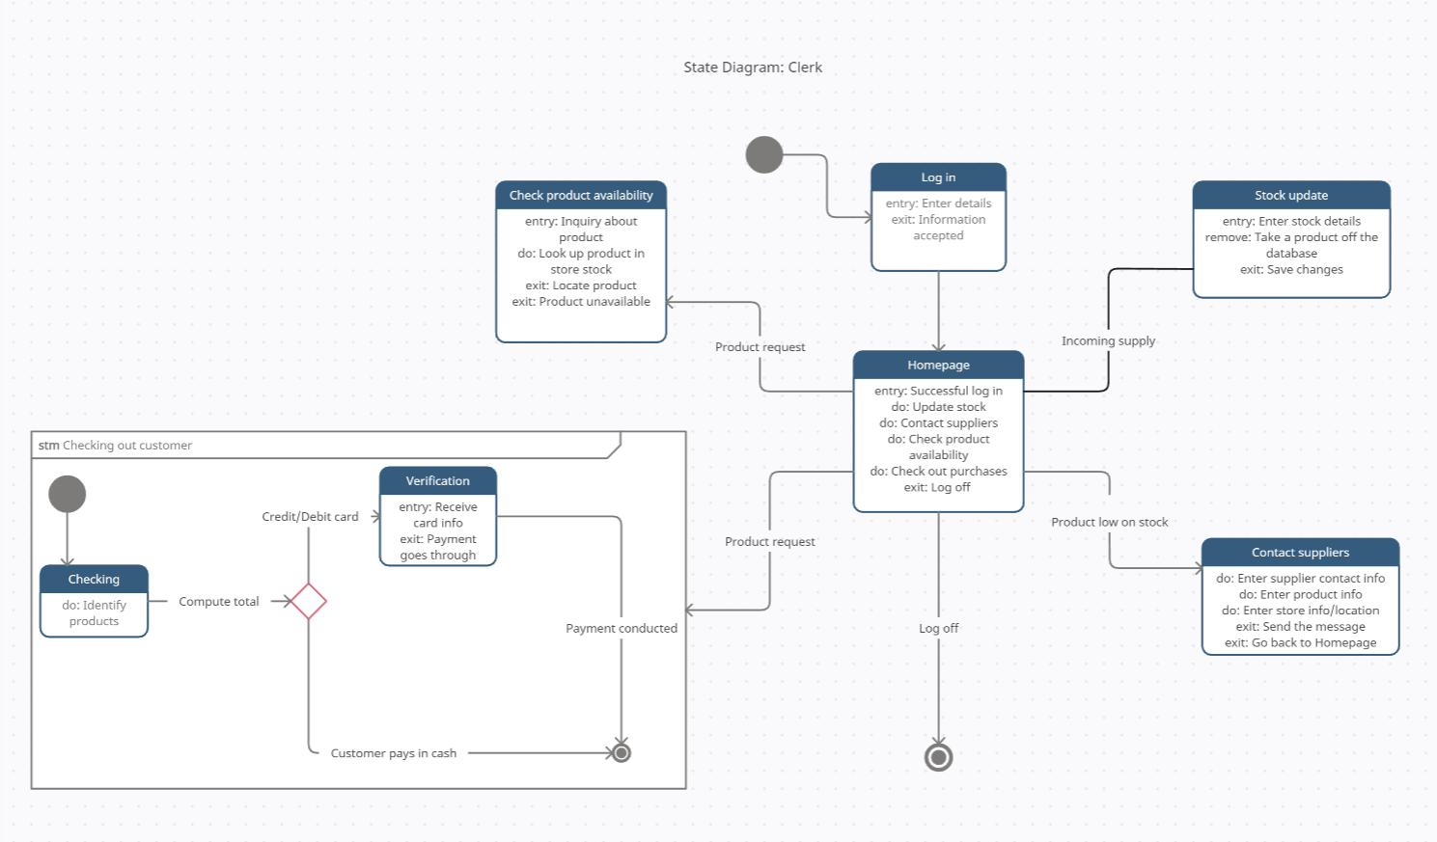

3. Manager

4.Admin/Owner

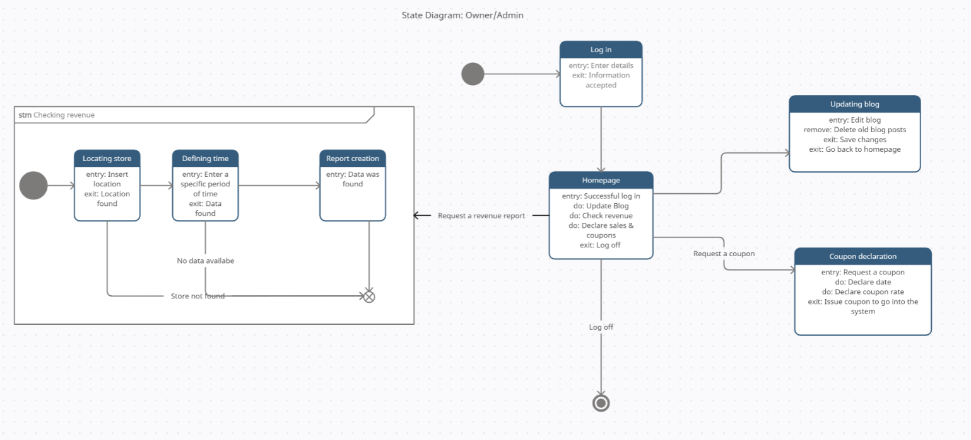

1. Wishlist

4.2 Activity Diagram

1. Coustumer creates account

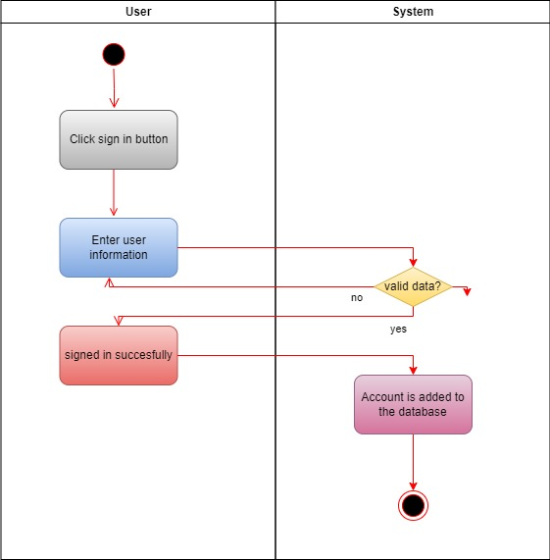

2. Items check

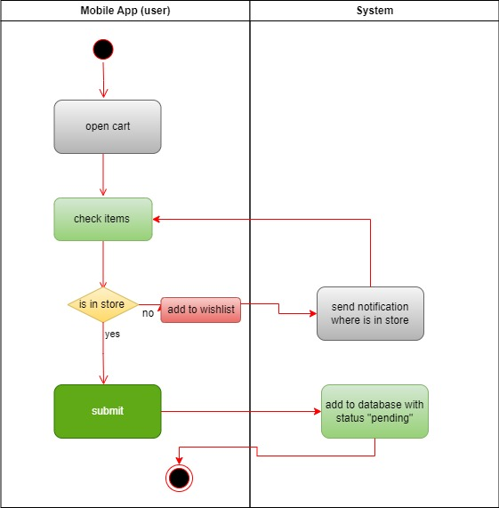

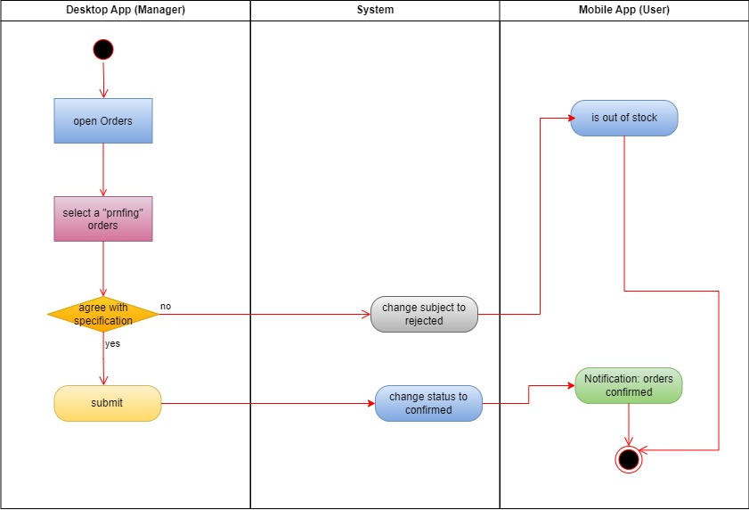3. owner open the orders

**4. User log in**

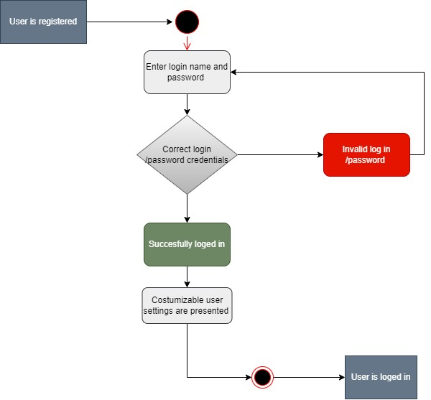  
  
  
  
  
  
  
  
  
  
  
  
  
  
  
  
  
  
  
  
  
  
  
  
  
  
  
  
  
  
  
  
  
  
  
  
  
  
  
  
  
  
  
  
  
  
  
  
  
  
  
  
  
  
  
  
  
  
  
  
  
  
  
  
  
**5. Purchasing a product**

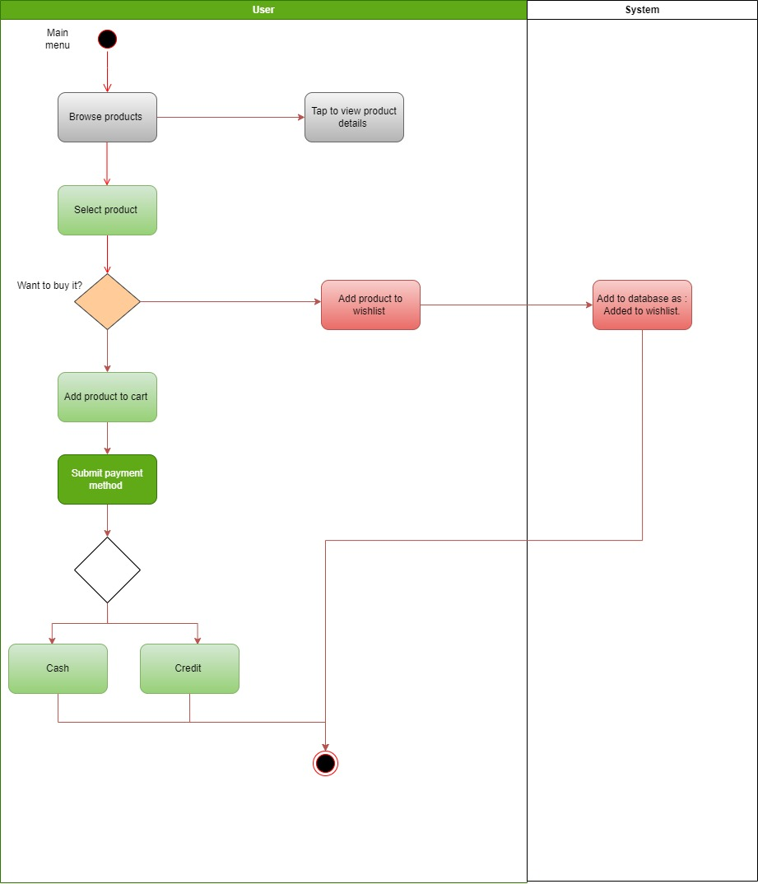  
  
  
**6.Adding a new product**   
  
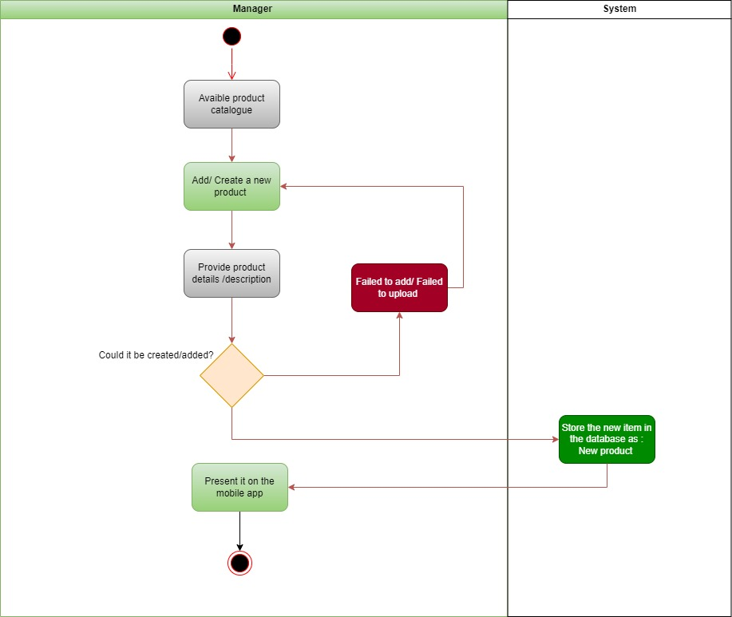  
  
  
  
  
  
  
  
  
  
  
  
  
  
APPENDIX

The appendixes are not always considered part of the actual Requirements Specification and are not always necessary. They may include

* Sample input/output formats, descriptions of cost analysis studies, or results of user surveys;
* Supporting or background information that can help the readers of the Requirements Specification;
* A description of the problems to be solved by the system;
* Special packaging instructions for the code and the media to meet security, export, initial loading, or other requirements.

When appendixes are included, the Requirements Specification should explicitly state whether or not the appendixes are to be considered part of the requirements.

1. **Definitions, Acronyms, and Abbreviations**

Define all terms, acronyms, and abbreviations used in this document.

1. **References**

List all the documents and other materials referenced in this document.

1. **Requirements Traceability Matrix**

The following trace matrix examples show one possible use of naming standards for deliverables (FunctionalArea-DocType-NN). The number has no other meaning than to keep the documents unique. For example, the Bargaining Unit Assignment Process Flow would be BUA-PF-01.

For example (1):

| **Business Requirement** | **Area** | **Deliverables** | **Status** |
| --- | --- | --- | --- |
| BR_LR_01  The system should validate the relationship between Bargaining Unit/Location and Job Class.---Comments: Business Process = "Assigning a Bargaining Unit to an Appointment" (Priority 1) | BUA | BUA-CD-01  Assign BU Conceptual Design | Accepted |
| BUA-PF-01  Derive Bargaining Unit-Process Flow Diagram | Accepted |
| BUA-PF-01  Derive Bargaining Unit-Process Flow Diagram | Accepted |
| BR_LR_09  The system should provide the capability for the Labor Relations Office to maintain the job class/union relationship.---Comments: Business Process = "Maintenance" (Priority 1) | BUA | BUA-CD-01  Assign BU Conceptual Design | Accepted |
| BUA-PF-02  BU Assignment Rules Maint Process Flow Diagram | ReadyForReview |

For example (2):

| **BizReqID** | **Pri** | **Major Area** | **DevTstItems DelivID** | **Deliv Name** | **Status** |
| --- | --- | --- | --- | --- | --- |
| BR_LR_01 | 1 | BUA | BUA-CD-01 | Assign BU Conceptual Design | Accepted |
| BR_LR_01 | 1 | BUA | BUA-DS-02 | Bargaining Unit Assignment DB Modification Description | Accepted |
| BR_LR_01 | 1 | BUA | BUA-PF-01 | Derive Bargaining Unit-Process Flow Diagram | Accepted |
| BR_LR_01 | 1 | BUA | BUA-UCD-01 | BU Assign LR UseCase Diagram | ReadyForReview |
| BR_LR_01 | 1 | BUA | BUA-UCT-001 | BU Assignment by PC UseCase - Add Appointment and Derive UBU | Reviewed |
| BR_LR_01 | 1 | BUA | BUA-UCT-002 | BU Assignment by PC UseCase - Add Appointment (UBU Not Found) | Reviewed |
| BR_LR_01 | 1 | BUA | BUA-UCT-006 | BU Assignment by PC UseCase - Modify Appointment (Removed UBU) | Reviewed |
| BR_LR_09 | 1 | BUA | BUA-CD-01 | Assign BU Conceptual Design | Accepted |
| BR_LR_09 | 1 | BUA | BUA-DS-02 | Bargaining Unit Assignment DB Modification Description | Accepted |
| BR_LR_09 | 1 | BUA | BUA-PF-02 | BU Assignment Rules Maint Process Flow Diagram | Accepted |
| BR_LR_09 | 1 | BUA | BUA-UCD-03 | BU Assign Rules Maint UseCase Diagram | Reviewed |
| BR_LR_09 | 1 | BUA | BUA-UCT-045 | BU Assignment Rules Maint: Successfully Add New Assignment Rule | Reviewed |
| BR_LR_09 | 1 | BUA | BUA-UCT-051 | BU Assignment Rules MaintUseCase: Modify Rule | Reviewed |
| BR_LR_09 | 1 | BUA | BUA-UCT-053 | BU Assignment Rules MaintUseCase - Review Assignment Rules | Reviewed |
| BR_LR_09 | 1 | BUA | BUA-UCT-057 | BU Assignment Rules MaintUseCase: Inactivate Last Rule for a BU | Reviewed |
| BR_LR_09 | 1 | BUA | BUA-UI-02 | BU AssignRules Maint UI Mockups | ReadyForReview |
| BR_LR_09 | 1 | BUA | BUA-TC-021 | BU Assignment Rules Maint TestCase: Add New Rule (Associated Job Class Does Not Exist) - Success | ReadyForReview |
| BR_LR_09 | 1 | BUA | BUA-TC-027 | BU Assignment Rules Maint TestCase: Modify Rule - Success | ReadyForReview |
| BR_LR_09 | 1 | BUA | BUA-TC-035 | BU Assignment Rules Maint TestCase: Add New Rule (Associated Job Class Does Not Exist) - Error Condition | ReadyForReview |
| BR_LR_09 | 1 | BUA | BUA-TC-049 | BU Assignment Rules Maint TestCase: Modify Rule - Error Condition | ReadyForReview |

For example (3):

| **BizReqID** | **CD01** | **CD02** | **CD03** | **CD04** | **UI01** | **UI02** | **UCT01** | **UCT02** | **UCT03** | **TC01** | **TC02** | **TC03** | **TC04** |
| --- | --- | --- | --- | --- | --- | --- | --- | --- | --- | --- | --- | --- | --- |
| BR_LR_01 |  |  | X |  | X |  | X |  |  | X |  | X |  |
| BR_LR_09 | X |  |  | X |  | X |  |  | X |  | X |  | X |
| BR_LR_10 | X |  |  | X |  |  |  |  | X |  | X |  |  |
| BR_LR_11 |  | X |  |  |  |  |  |  |  |  |  |  |  |

1. **Organizing the Requirements**

This section is for information only as an aid in preparing the requirements document.

Detailed requirements tend to be extensive. Give careful consideration to your organization scheme. Some examples of organization schemes are described below:

**By System Mode**

Some systems behave quite differently depending on the mode of operation. For example, a control system may have different sets of functions depending on its mode: training, normal, or emergency.

**By User Class**

Some systems provide different sets of functions to different classes of users. For example, an elevator control system presents different capabilities to passengers, maintenance workers, and fire fighters.

**By Objects**

Objects are real-world entities that have a counterpart within the system. For example, in a patient monitoring system, objects include patients, sensors, nurses, rooms, physicians, medicines, etc. Associated with each object is a set of attributes (of that object) and functions (performed by that object). These functions are also called services, methods, or processes. Note that sets of objects may share attributes and services. These are grouped together as classes.

**By Feature**

A feature is an externally desired service by the system that may require a sequence of inputs to affect the desired result. For example, in a telephone system, features include local call, call forwarding, and conference call. Each feature is generally described in a sequence of stimulus-response pairs, and may include validity checks on inputs, exact sequencing of operations, responses to abnormal situations, including error handling and recovery, effects of parameters, relationships of inputs to outputs, including input/output sequences and formulas for input to output.

**By Stimulus**

Some systems can be best organized by describing their functions in terms of stimuli. For example, the functions of an automatic aircraft landing system may be organized into sections for loss of power, wind shear, sudden change in roll, vertical velocity excessive, etc.

**By Response**

Some systems can be best organized by describing all the functions in support of the generation of a response. For example, the functions of a personnel system may be organized into sections corresponding to all functions associated with generating paychecks, all functions associated with generating a current list of employees, etc.

**By Functional Hierarchy**

When none of the above organizational schemes prove helpful, the overall functionality can be organized into a hierarchy of functions organized by common inputs, common outputs, or common internal data access. Data flow diagrams and data dictionaries can be used to show the relationships between and among the functions and data.

**Additional Comments**

Whenever a new Requirements Specification is contemplated, more than one of the organizational techniques given above may be appropriate. In such cases, organize the specific requirements for multiple hierarchies tailored to the specific needs of the system under specification.

There are many notations, methods, and automated support tools available to aid in the documentation of requirements. For the most part, their usefulness is a function of organization. For example, when organizing by mode, finite state machines or state charts may prove helpful; when organizing by object, object-oriented analysis may prove helpful; when organizing by feature, stimulus-response sequences may prove helpful; and when organizing by functional hierarchy, data flow diagrams and data dictionaries may prove helpful.

